# How to Make the Most of Google My Business Features

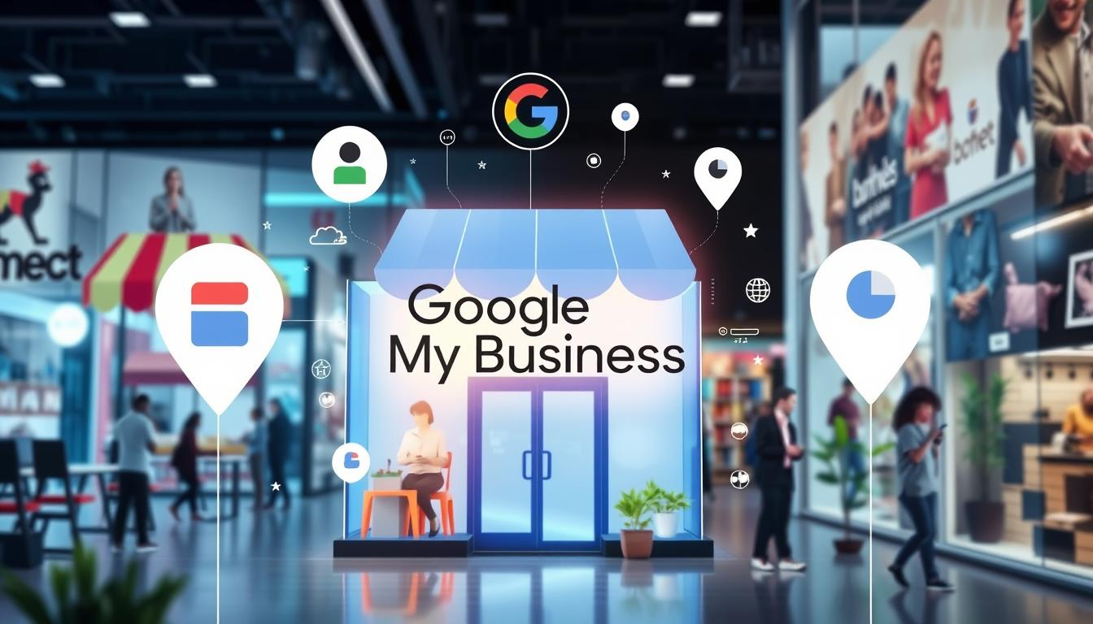In today's world, local businesses must have strong tools to shine online. Google My Business (GMB) is key for reaching out to customers and boosting **local SEO**. This guide will show you how to use **GMB features** to improve your online presence and draw in more local customers.

**GMB optimization** is now a must for businesses to compete online. Whether you run a small coffee shop or a big service company, using Google My Business wisely can help. We'll show you how to use these digital marketing tools to your advantage.

### Key Takeaways

* Understand the critical role of GMB in **local search visibility**
* Learn how to maximize **GMB features** for business growth
* Discover strategies for improving **local SEO** performance
* Implement advanced techniques for online customer engagement
* Transform your digital presence with targeted **GMB optimization**

## Understanding Google My Business Fundamentals

Google My Business (GMB) is key for local businesses to boost their online presence. It changes how companies meet potential customers online.

To improve your GMB profile, focus on **local search visibility**. Knowing and using key profile parts can boost your **google maps ranking**.

### Key Components of a GMB Profile

A good GMB profile has important parts for managing location data:

* Accurate business name and address
* Precise contact information
* Business category selection
* Operating hours
* High-quality images and videos

### Why GMB Matters for Local Businesses

"Your online presence is your digital storefront - make it count!" - Digital Marketing Experts

GMB gives businesses big chances to:

1. Boost online visibility
2. Draw in local customers
3. Gain trust with customer reviews
4. Share business info right away

### Setting Up Your GMB Account Correctly

Creating a great GMB profile needs careful planning and detail. Make sure all info is correct to improve local search.

| GMB Profile Element | Importance | Impact on Search Ranking |
| --- | --- | --- |
| Business Name | Critical | High |
| Address Verification | Essential | Very High |
| Category Selection | Crucial | Moderate to High |

*Pro tip: Keep your GMB profile up to date for better search rankings and customer interaction.*

## GMB optimization, GMB features, local SEO: Essential Strategies

https://www.youtube.com/watch?v=8ET44Ai5SSw

**Local SEO** needs a smart plan for Google My Business (GMB) optimization. Businesses can boost their online presence by using key **GMB features** and **local citation building** techniques.

Start your **GMB optimization** with a detailed profile. Your plan should include:

* Complete and accurate business information
* Consistent local citations across digital platforms
* Strategic use of keywords in business descriptions
* Regular profile updates and engagement

"Your Google My Business profile is your digital storefront—make it count!" - Local SEO Experts

**Local citation building** is key in GMB optimization. *Citations are online mentions of your business name, address, and phone number*. They help search engines see your business as credible and local.

Key local SEO tactics include:

1. Verify and claim your GMB listing
2. Select accurate business categories
3. Add high-quality, relevant photos
4. Encourage customer reviews

By using these GMB features and local SEO strategies, businesses can improve their online presence. They can also attract more local customers.

## Optimizing Your Business Information for Maximum Visibility

To have a strong online presence, managing your business info is key. Google My Business (GMB) helps local businesses boost their online presence. It does this through precise signals and optimizing local content.

Managing your business info is more than just listing details. It's about creating a detailed digital profile. This profile should draw in potential customers and boost your search engine ranking.

### NAP Consistency Across Platforms

Keeping your Name, Address, and Phone number (NAP) the same everywhere is vital. If these details are different, it can confuse people and hurt your search ranking.

* Verify NAP details on GMB, website, social media, and directory listings
* Use identical formatting for business name and contact information
* Update changes immediately across all platforms

### Category and Attribute Selection

Picking the right categories and attributes helps Google know what your business is about. This makes your business show up in local searches better.

| Category Selection Tips | Impact on Visibility |
| --- | --- |
| Choose most specific primary category | Improves search relevance |
| Add 2-3 secondary categories | Expands search potential |
| Use accurate business attributes | Enhances user understanding |

### Service Area Configuration

Setting up your service area clearly tells customers where you operate. This is crucial for businesses that cover many areas or offer mobile services.

"Accurate service area information builds trust and improves local search performance." - Local SEO Expert

By using these strategies, businesses can greatly boost their online visibility. They can also attract more local customers with targeted digital marketing.

## Leveraging Google My Business Posts

Google My Business (GMB) posts are a great way for businesses to connect with potential customers. They show up in search results, letting you share what makes your business special. This is a quick way to show off your unique offerings and personality.

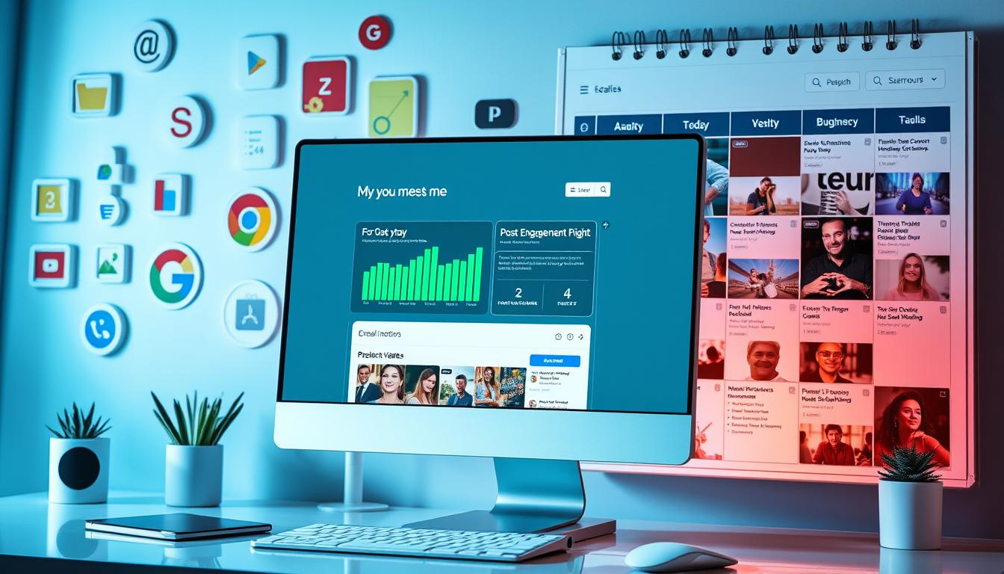There are many types of GMB posts that can help you stand out in local searches:

* Event Posts: Highlight upcoming activities or special gatherings
* Offer Posts: Share promotional deals and discounts
* Update Posts: Communicate recent business developments
* Product Posts: Showcase specific items or services

Creating effective GMB posts takes some planning. Use eye-catching visuals, clear calls-to-action, and short, catchy messages. This will grab potential customers' attention fast.

"Great GMB posts transform your business listing from static information to an interactive marketing platform."

Posting regularly is key. Try to update your GMB profile at least once a week. This keeps your content fresh and boosts your **local search visibility**. Each post stays up for seven days, giving you chances to keep engaging with your audience.

| Post Type | Best Use | Recommended Frequency |
| --- | --- | --- |
| Event Posts | Upcoming Business Activities | 1-2 weeks before event |
| Offer Posts | Time-Limited Promotions | Every 2-3 weeks |
| Update Posts | Business News/Changes | Weekly |

By using these strategies, businesses can turn their Google My Business profile into a lively marketing tool. It helps attract and keep local customers interested.

## Mastering GMB Photo and Video Features

Visual content is key to drawing in customers and boosting your local search ranking. Google My Business offers unique chances to show off your brand with eye-catching images and videos.

Good visual storytelling can make your Google My Business profile stand out. The right images and videos help people get a quick idea of what you do.

### Image Optimization Best Practices

* Upload high-resolution images (at least 720 pixels wide)
* Include diverse photo types:
  + Exterior storefront shots
  + Interior workspace images
  + Product or service demonstrations
  + Team or staff photographs
* Ensure images are professionally edited and clear
* Rotate images regularly to keep content fresh

### Video Content Guidelines

Videos are a great way to boost your local search visibility. Make short, engaging clips that show off what makes your business special.

1. Keep videos between 30-90 seconds
2. Showcase product demonstrations
3. Feature customer testimonials
4. Provide behind-the-scenes glimpses

### Virtual Tour Implementation

A virtual tour can be a big win for your Google My Business profile. It lets potential customers check out your space before visiting, building trust and interest.

"A picture is worth a thousand words, but a virtual tour is worth a thousand customers." - Digital Marketing Experts

Professional virtual tours can greatly enhance your local search visibility. They offer an immersive experience that makes you stand out from competitors.

## Managing and Responding to Customer Reviews

https://www.youtube.com/watch?v=OX4XSxuy4hQ

Customer reviews are very important for local SEO and managing reviews. They show how good your business is and can help your search rankings. It's important to know how to handle and reply to reviews to gain trust from potential customers.

To manage reviews well, follow these steps:

* Encourage customers to leave real feedback
* Reply quickly and nicely to all reviews
* Deal with negative reviews by being understanding and offering solutions
* Keep an eye on review sites all the time

Here are some tips for responding to reviews for local SEO:

1. Thank people for good reviews with personal messages
2. Apologize and fix problems for bad experiences
3. Keep your answers short and real
4. Show you care about making customers happy

"Your response to reviews can be more important than the review itself." - Digital Marketing Expert

Negative reviews are chances to get better. They give you insights into what customers think and how you can improve.

To manage reviews well for local SEO, use tools to track and analyze feedback on different sites. This helps keep your online reputation strong and lets you always get better at what you do.

## Utilizing GMB Messaging and Q&A Features

Google My Business (GMB) has great tools for talking to customers. Messaging and Q&A features let people reach out to you. This is a chance to show off your knowledge and how quick you are to respond.

### Setting Up Auto-Responses

Automated messages can change how you talk to customers. With GMB, you can:

* Create instant welcome messages
* Set up default response templates
* Provide immediate customer support

### Managing Customer Inquiries Effectively

Quick and clear answers are important for being seen online. Here's how to handle messages:

1. Respond within 24 hours
2. Use clear and concise language
3. Address specific customer questions

### Building a Comprehensive Q&A Strategy

The Q&A section on your GMB profile is very useful. *Proactively populate this section with frequently asked questions*. This shows you know your stuff and care about your customers.

"Your GMB profile is often the first point of contact for potential customers. Make it count!" - Local SEO Expert

Using GMB messaging and Q&A features well can boost your online presence. It also helps you talk to customers better. This can bring more people to your business.

## Implementing GMB Products and Services

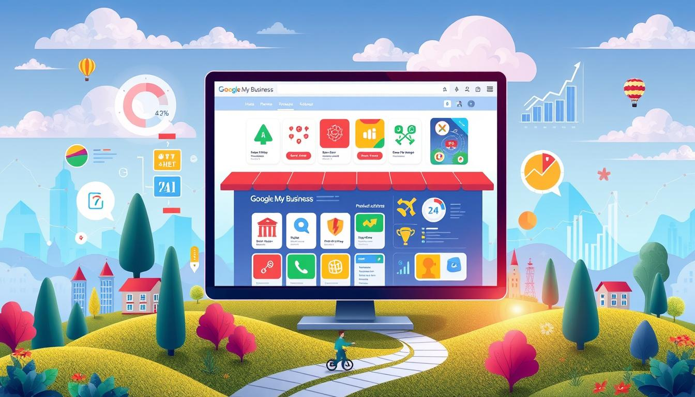Google My Business (GMB) is a great tool for local businesses. It helps them show off their products and services well. By using GMB features, companies can make their local content stand out. This attracts more customers and improves their local search rankings.

Listing products and services needs a smart plan. Business owners should write detailed, interesting descriptions. They should include clear prices, good images, and specific details that show they know their stuff.

* Upload professional product images
* Write compelling product descriptions
* Update pricing information regularly
* Highlight seasonal or special offerings

"Your GMB product listings are your digital storefront - make them count!" - Local Marketing Expert

Here are some key strategies for optimizing product listings:

| Strategy | Impact | Implementation |
| --- | --- | --- |
| Visual Quality | High engagement | Professional, clear product images |
| Detailed Descriptions | Improved search visibility | Use relevant keywords naturally |
| Pricing Transparency | Customer trust | Update prices consistently |

Managing GMB products for **local content optimization** is an ongoing task. Keep your listings up to date, answer customer questions, and make sure all info is correct and current.

## Analyzing GMB Insights and Metrics

Knowing how your Google My Business (GMB) profile performs is key for local search success. GMB optimization uses data to guide business decisions and boost online presence.

Data analytics give a full picture of online customer interactions. These metrics show how users engage and search for your business.

### Understanding Performance Analytics

Important GMB metrics include:

* Total profile views
* Search appearance frequency
* Customer interaction rates
* Website click-through percentages

### Tracking Customer Actions

The GMB dashboard tracks customer interactions:

1. *Website clicks* show direct interest
2. Phone call requests show engagement
3. Direction requests indicate potential foot traffic

"Data transforms guesswork into strategic marketing decisions." - Digital Marketing Expert

### Monitoring Competitor Activity

Competitive analysis through GMB insights helps understand your local market position. By comparing metrics, you can find ways to improve your local search visibility and stand out.

Regularly reviewing these analytics helps improve your GMB strategy. This keeps your business competitive and visible in local search results.

## Creating Location-Specific Content

**Local content optimization** is a key strategy for businesses aiming to top local SEO. By making content that talks directly to your community, you can greatly boost your online presence. This also helps you connect better with potential customers.

https://www.youtube.com/watch?v=RtN7iD-zqxY

To make location-specific content, you need a smart plan. Here are some important tactics to boost your local SEO:

* Create blog posts about local events and community activities
* Showcase local customer success stories
* Write about neighborhood-specific challenges and solutions
* Feature local team members and their community involvement

"Content that resonates with local audiences builds trust and credibility faster than generic marketing materials." - Local Marketing Experts

Your content strategy should aim to answer local search queries. Use regional keywords, talk about local challenges, and offer real value to your community.

| Content Type | Local SEO Impact | Engagement Potential |
| --- | --- | --- |
| Community Event Recap | High | Excellent |
| Local Problem-Solving Guide | Very High | Strong |
| Neighborhood Business Spotlight | Moderate | Good |

Use user-generated content and local partnerships to improve your location-specific content strategy. Ask customers to share their stories and work with other local businesses. This way, you can create valuable, location-focused content that boosts your local SEO.

## Integrating GMB with Your Overall Marketing Strategy

To create a smooth marketing plan, link your Google My Business (GMB) profile with your digital marketing. This way, you can boost your local online presence and attract more people.

### Social Media Synchronization

Linking your GMB profile with social media is a smart move for local marketing. Here's how to do it:

* Cross-post GMB updates on social media
* Share customer reviews on different platforms
* Use the same branding and messages everywhere
* Make content specific to your location

### Website Integration Techniques

To improve local citations, make your website and GMB profile work together. Here are some tips:

1. Put GMB reviews on your website
2. Keep your NAP (Name, Address, Phone) info the same
3. Create pages for each location
4. Add GMB links in your website's footer

### Local SEO Alignment

For local SEO to work, you need a complete plan that ties GMB to your digital marketing. *Having a consistent online presence shows search engines and customers you're reliable.*

"Your online presence should tell a unified story across all digital platforms." - Local Marketing Expert

## Conclusion

Mastering Google My Business (GMB) features is key for businesses wanting to lead in local search. GMB optimization boosts your online presence and connects you with local customers. By using the tips from this guide, you can improve your local SEO and stand out online.

Success in local SEO comes from regularly updating and improving your GMB profile. It's a continuous effort that needs careful attention and smart planning. Your GMB features are a powerful marketing tool that can increase your visibility, draw in more customers, and offer insights into your local audience.

As digital marketing changes, staying ahead with GMB optimization is crucial. Small businesses and local companies can use these tools to build a strong online presence that brings real results. Remember, your GMB profile is often the first thing potential customers see, so make it count.

Start by checking your Google My Business profile, apply the strategies mentioned, and keep an eye on your local search performance. The digital world rewards businesses that are quick to adapt, strategic, and focused on adding value to their community.

## FAQ

### What is Google My Business (GMB) and why is it important for local businesses?

Google My Business is a free tool for managing your online presence. It's key for local businesses. It boosts local search visibility and helps customers find your info. This increases your chances of showing up in local searches and Google Maps.

### How do I set up a Google My Business profile?

To start a GMB profile, go to the Google My Business website. Sign in with your Google account. Then, follow these steps: - Verify your business name and address - Choose your business category - Add your contact information - Upload high-quality photos - Verify your business through a postcard, phone, or email

### How can I optimize my Google My Business listing?

To make your GMB listing better, focus on: - Keeping NAP (Name, Address, Phone number) consistent - Adding complete and accurate info - Picking the right business categories - Uploading top-notch photos - Encouraging and responding to reviews - Keeping your info and posts up to date

### Why are customer reviews important for my GMB profile?

Reviews are vital because they: - Boost your local search rankings - Build trust with potential customers - Show your business quality - Offer feedback for improvement - Increase local search visibility

### How often should I update my Google My Business profile?

Update your GMB profile often. Try to: - Post weekly about events, offers, or updates - Review your info monthly - Update immediately for any changes - Refresh photos and content regularly - Reply quickly to new reviews

### What types of posts can I create on Google My Business?

You can post many things on GMB, like: - Event announcements - Promotions - Product showcases - Business updates - COVID-19 info - Service announcements

### How do GMB photos impact my local search visibility?

Good photos can really help your local search visibility. They: - Increase user engagement - Show what your business looks like - Help customers understand what you offer - Make your listing stand out - Improve your profile's completeness

### What are GMB Insights, and how can they help my business?

GMB Insights give you data on how people find and interact with your listing. They show: - Profile views - Search queries - Customer actions (website clicks, calls, directions) - Photo views and engagement - Help you improve your local marketing

### How can I improve my local SEO through Google My Business?

To boost local SEO, do: - Keep your business info consistent - Build local citations - Encourage reviews - Create local content - Use local keywords in your description - Update your GMB profile regularly - Share local, relevant posts

### Are there any common mistakes to avoid with Google My Business?

Avoid these GMB mistakes: - Inaccurate or incomplete info - Inconsistent NAP - Ignoring reviews - Not updating regularly - Using low-quality photos - Not verifying your listing - Choosing wrong business categories